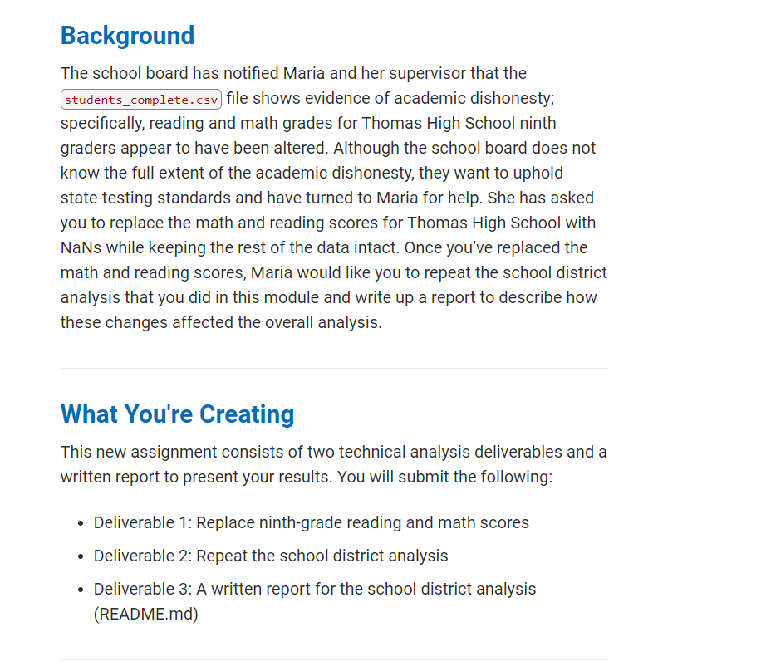

Old District Summary (first from instructions and second from PyCitySchools before formatting as has unrounded numbers

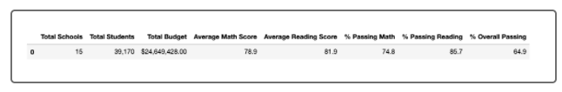

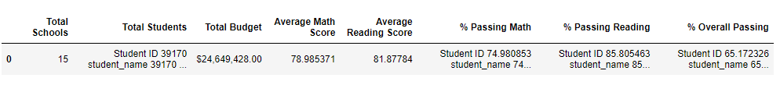

New District Summary (Line 13) – second has more digits



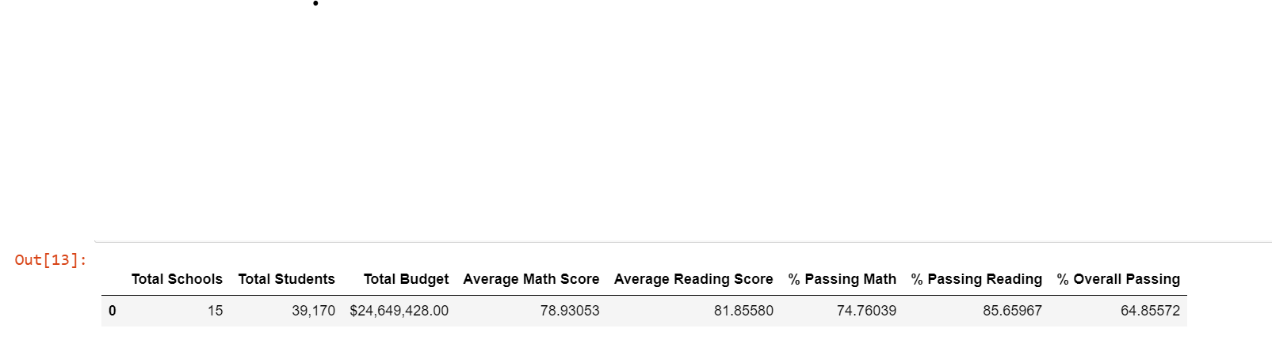

Old School Summary (Line 73):

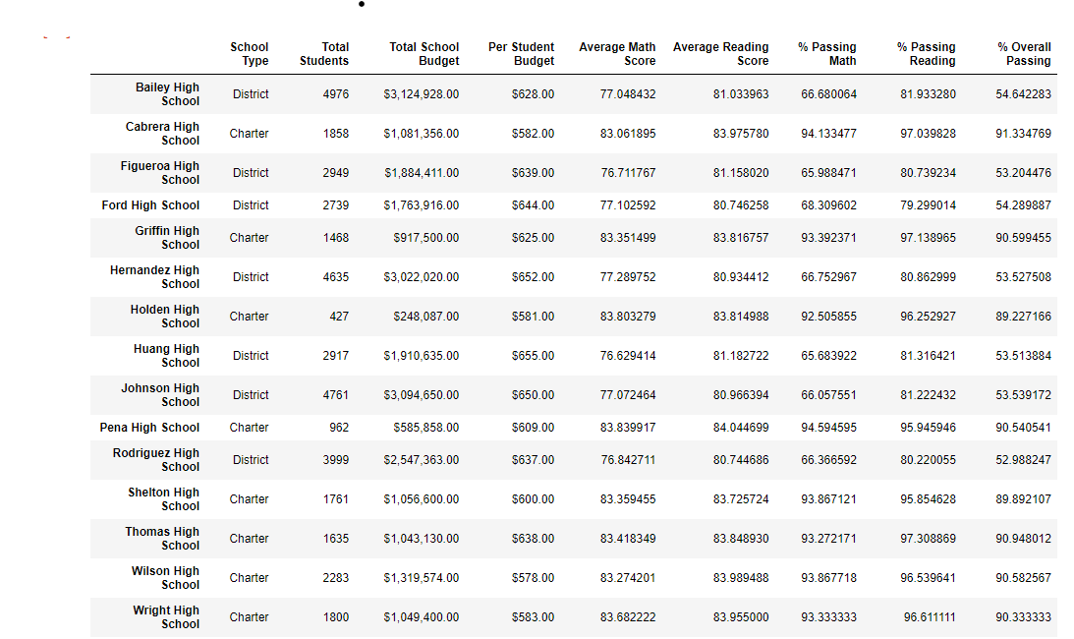

New School Summary (Line 30):

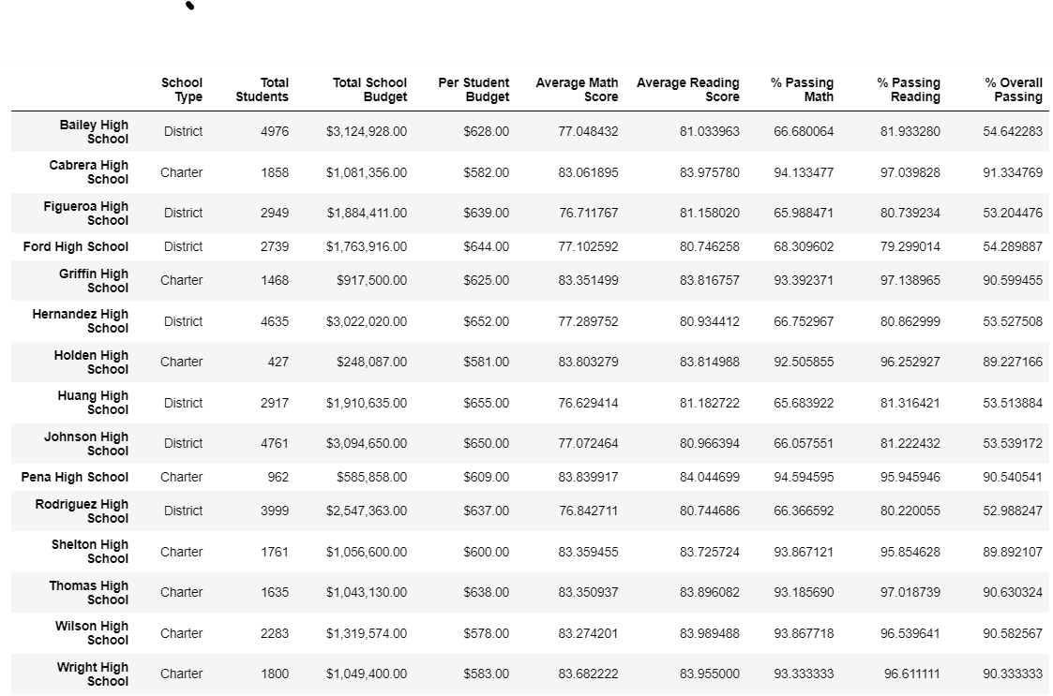

OLD MATH BY GRADE (LINE 105):

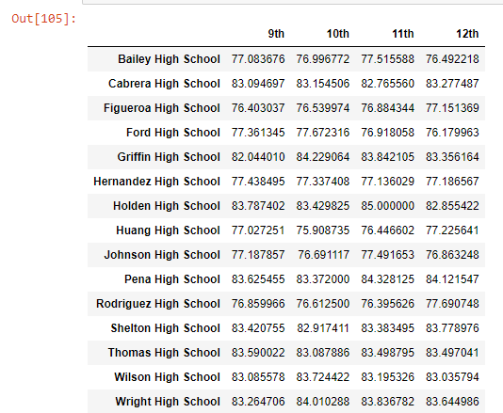

NEW MATH BY GRADE (LINE 53):

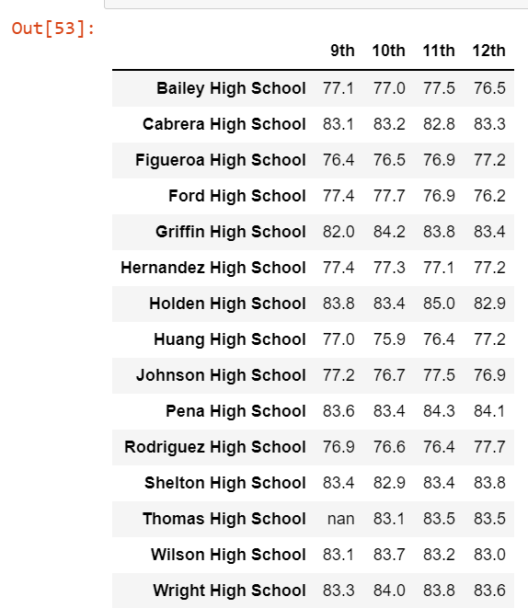

OLD READING BY GRADE (LINE 106):

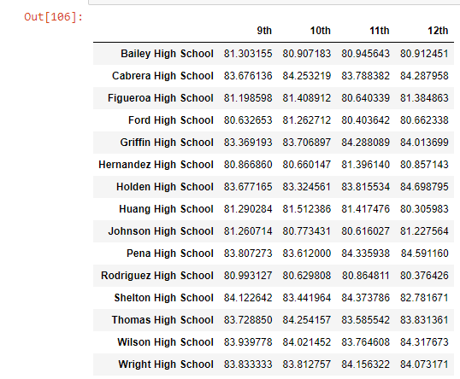

NEW READING BY GRADE (LINE 54):

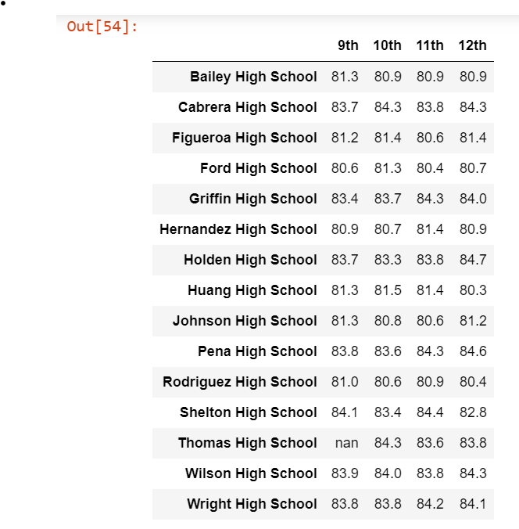

OLD SCORES BY SCHOOL SPENDING (LINE 94)

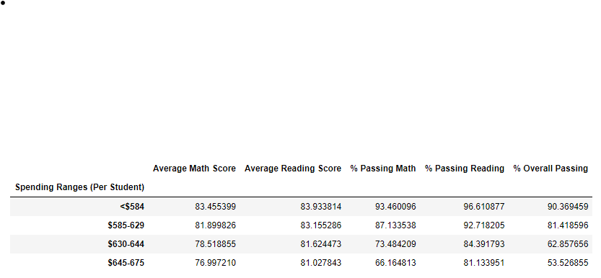

NEW SCORES BY SCHOOL SPENDING (LINE 41)

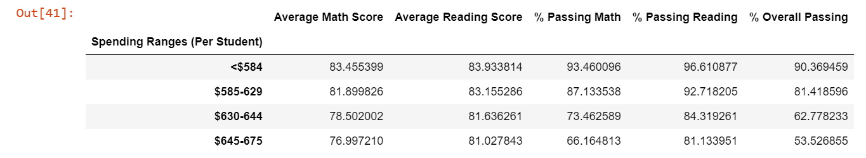

OLD SCORES BY SCHOOL SIZE (LINE 100)

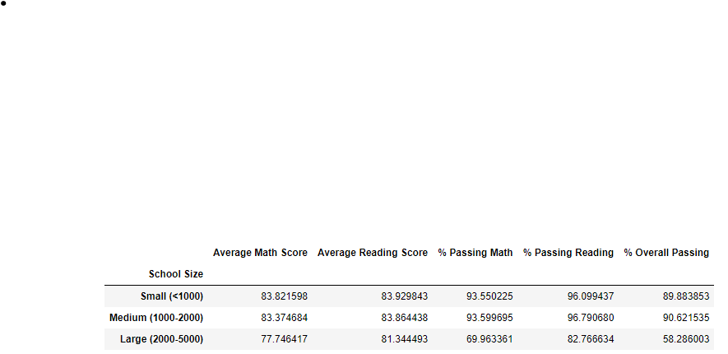

NEW SCORES BY SCHOOL SIZE (LINE 63)

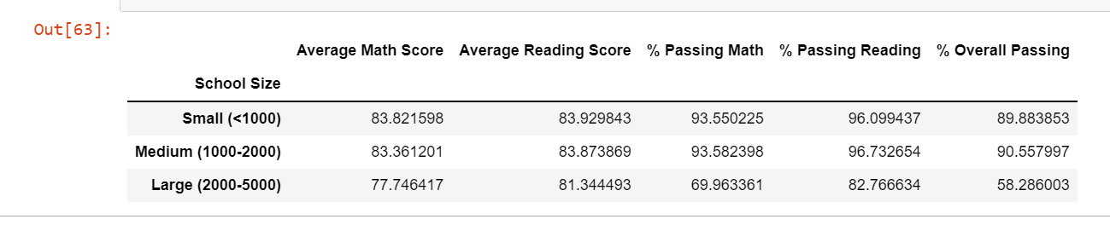

OLD SCORES BY SCHOOL TYPE (LINE 103)

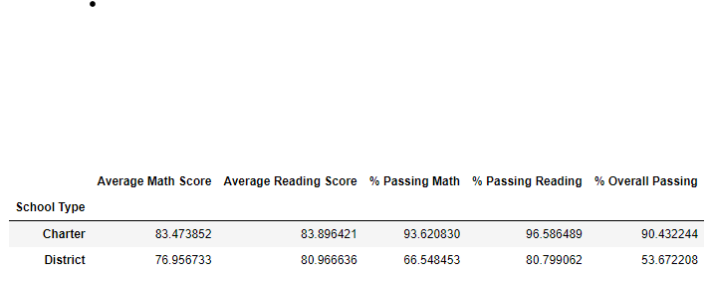

NEW SCORES BY SCHOOL TYPE (LINE 66)

